A000-Asia-China-Hongshan-jade-three-hole, double-boar device-with tenon-4700-2920 BCE





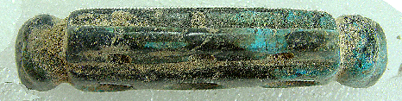

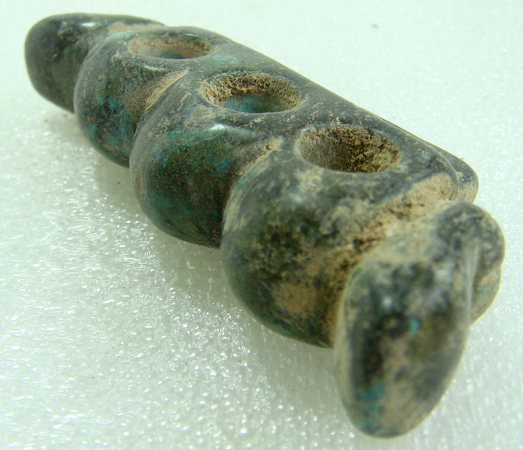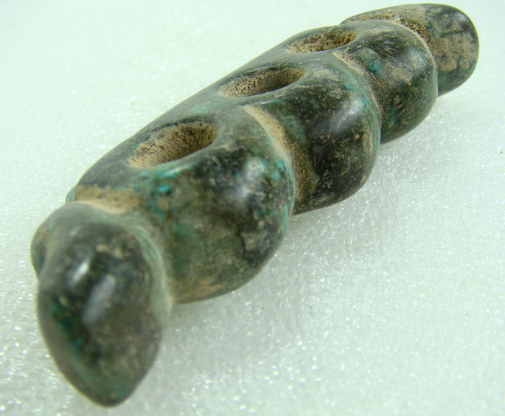



Hongshan-jade-three-hole, double-boar device-with tenon-4700-2920 BCE

Case no.: 5

Accession Number:

Formal Label: Hongshan-jade-three-hole, double-boar device-with tenon-4700-2920 BCE

Display Description:

Hongshan jade three-hole devices are an integral part of the symbolism that was used to characterize the domesticated boar fetus. In this case three tori are sandwiched between two boar heads. The three curves on the top surface of this artifact are thought to signify a mountain ridge, perhaps where wild boars were sought.

LC Classification: GN776.3.H58

Date or Time Horizon: 4700-2920 BCE

Geographical Area: western Liaoning province

Map:

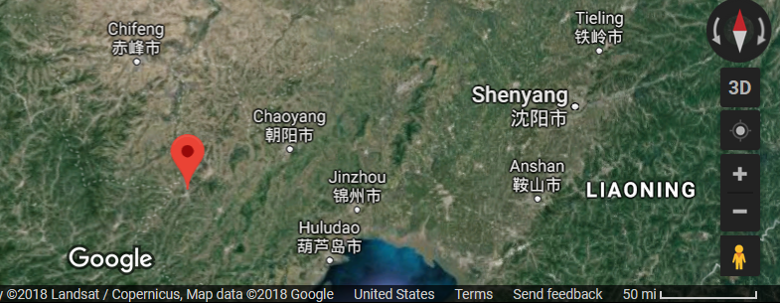

GPS coordinates: [41°15′N 119°24′E](https://tools.wmflabs.org/geohack/geohack.php?pagename=Lingyuan&params=41_15_N_119_24_E_region:CN-21_type:city)

Cultural Affiliation: Hongshan

Medium: Jade

Dimensions: L 3.4 in, H 1.2 in, W 0.6 in

Weight: 58 gm

Condition: original

Provenance: collected near San Guan Dian Zi Cun, Lingyuan City, Liaoning Province in 1979

Discussion:

The tenon may have fit into a comb base.

References: